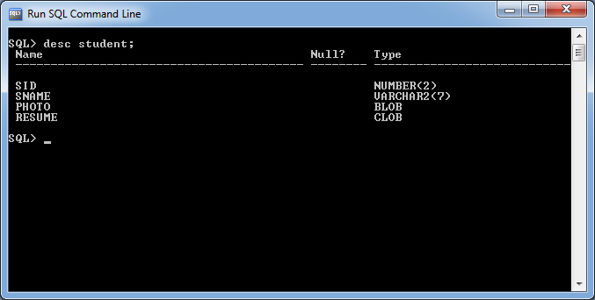

**package** com.raos;

**import** java.io.FileInputStream;

**import** java.io.FileNotFoundException;

**import** java.io.FileReader;

**import** java.io.IOException;

**import** java.sql.Connection;

**import** java.sql.DriverManager;

**import** java.sql.PreparedStatement;

**import** java.sql.SQLException;

**import** java.util.Scanner;

**public** **class** Sample {

**public** **static** String *query*="insert into student values(?,?,?,?)";

**public** **static** **void** main(String[] args) **throws** IOException{

**try**(Connection con=DriverManager.*getConnection*("jdbc:oracle:thin:@localhost:1521:xe","sukumar","sukumar");

PreparedStatement ps=con.prepareStatement(*query*);

Scanner s=**new** Scanner(System.***in***))

{

System.***out***.print("Enter the photo path:");

String path=s.next().trim().replace("?","");

System.***out***.print("Enter the Resume:");

String bdata=s.next();

**try**(

FileInputStream fs=**new** FileInputStream(path);

FileReader fr=**new** FileReader(bdata))

{ ps.setInt(1, 1);

ps.setString(2,"suku");

ps.setBinaryStream(3,fs);

ps.setCharacterStream(4,fr);

**int** count=ps.executeUpdate();

**if**(count==1) {

System.***out***.println("record Inserted");

}

**else**

{

System.***out***.println("Record not Inserted");

}

}

**catch**(FileNotFoundException f) {

System.***out***.println(f.getMessage());

}

}

**catch**(SQLException s) {

System.***out***.println(s.getMessage());

}

}//main

}//class

Output:-

Enter the photo path:D:\\kalam.jpg

Enter the Resume:D:\\suku.txt

record Inserted